A mistake in copying DNA can result in dwarfism.

This photo shows a family in which both parents have normal height, but their daughter has a type of dwarfism called achondroplasia. The average height of an adult with achondroplasia is a little over 4 feet. Achondroplasia is caused by a single dominant allele of a gene for a protein that regulates bone growth.

1. Suggest a genetic explanation for how these parents could have a daughter who has achondroplasia, even though neither parent had achondroplasia.

To begin our analysis, the table below shows the effects of the alleles of the gene that can cause achondroplasia.

Genotype | → | Protein | → | Characteristics
dd | → | Normal regulator protein that inhibits bone growth enough to result in normal adult height | → | Person has normal height and mortality risk.
Dd | → | Both normal regulator protein and overactive regulator protein | → | Person is very short and has somewhat elevated mortality risk; person has achondroplasia.
DD | → | Overactive regulator protein that excessively inhibits bone growth | → | Abnormalities are so severe that the fetus dies before birth or the baby dies shortly after birth.

2a. Which genotype results in achondroplasia? DD ___ Dd ___ dd ___

2b. Explain why each of the other two genotypes do not result in achondroplasia.

3a. What were the genotypes of the parents in the family shown above?
DD ___ Dd ___ dd ___

3b. What was the genotype of their daughter? DD ___ Dd ___ dd ___
Although the father did not have a D allele, there was a D allele in the sperm that fertilized the egg to produce the zygote that developed into the daughter. How did this happen?

This figure shows that sperm production requires both  - mitosis (to replenish the supply of sperm stem cells) and  - meiosis (to produce the haploid cells that differentiate into sperm).  Before mitosis or meiosis, a cell must replicate its DNA.  A mistake in DNA replication can cause a mutation that converts a d allele to a D allele. Only a very small mistake is needed to produce this mutation, since the d and D alleles differ in only one nucleotide out of more than 1000 nucleotides in the gene.  4a. What is DNA replication?  4b. Mark each cell that carries out DNA replication with an *.  5. Explain how a mistake in copying DNA can result in an offspring who has dwarfism. (A complete answer will include mitosis, meiosis, mutation, allele, sperm, fertilizes, egg, protein, and bone growth.) | 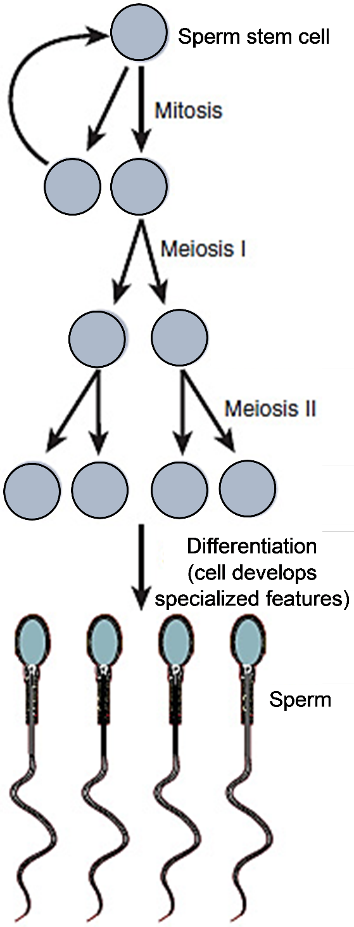

Challenge Question
6. The risk that an offspring will have achondroplasia increases as the father’s age increases. Suggest a hypothesis that could explain why.

7a. Draw a Punnett square for two parents who both have achondroplasia.

7b. Circle each genotype which would result in a child with achondroplasia.

7c. Use an * to mark the genotype that would result in a child with normal height.

7d. What would happen to a zygote with the DD genotype?

Approximately 20% of cases of achondroplasia are due to inheritance of a D allele from a parent with achondroplasia. Approximately 80% of cases of achondroplasia are caused by a new mutation, which changes a d allele to a D allele. Thus, achondroplasia is a genetic condition, but usually it is not hereditary.

8. Explain what it means to say, “Her achondroplasia is a genetic condition, but not a hereditary condition.” (This is true for the daughter described on the first page.)

9a. Based on the frequency of dwarfs among the people you have seen in your lifetime, what genotype do most people have? DD ___ Dd ___ dd ___

9b. Why is the D allele considered dominant, even though this allele is rare?

10. Explain how the gene that can cause achondroplasia illustrates the generalization that “A single gene often has more than one effect.” (Hint: See the table on page 1.)

By Dr. Ingrid Waldron, Dept. Biology, Univ. Pennsylvania, © 2023. This Student Handout and Teacher Notes (with instructional suggestions and background information) are available at https://serendipstudio.org/exchange/bioactivities/geneticsdwarf

